Nifty100 Project Business Insights
DASHBOARDS INSIGHTS

Page 1 — Executive Overview Insights:-

• 45 companies fall under the MODERATE financial health category, indicating balanced but improvable performance.
• Strong-rated companies maintain significantly lower debt ratios and higher profitability scores.
• Weak-rated companies generally show high leverage and unstable cash flow positions.
• The average ML health score of 75.78 suggests an overall stable market condition across Nifty100 firms.
• Debt-to-equity ratio shows a strong inverse relationship with overall financial health.

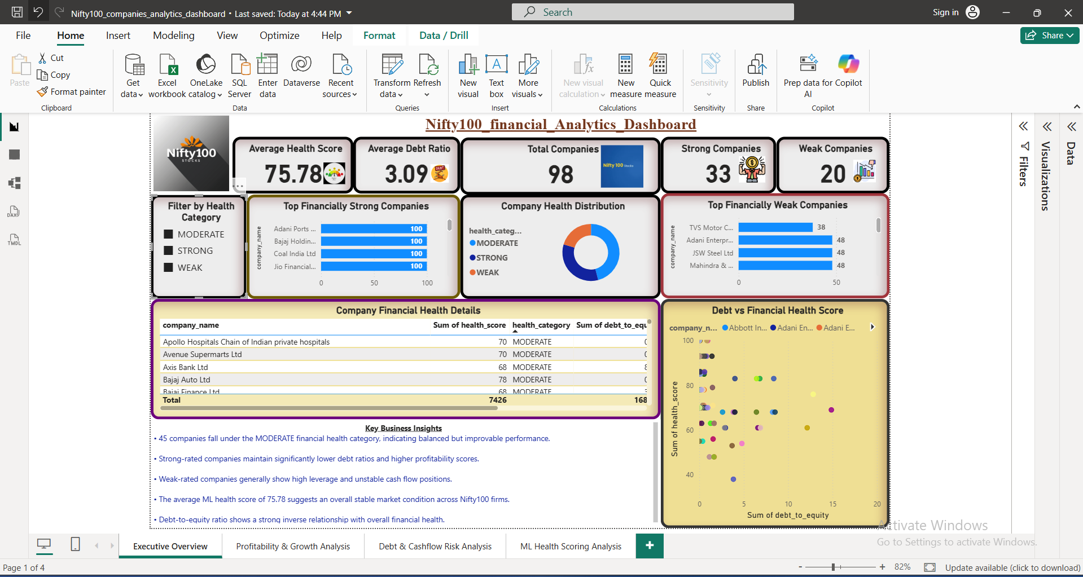
Page 2 — Profitability & Growth Insights:-

• Strong-rated companies maintain the highest average profit margins, reflecting efficient operational performance.
• Several firms continue to operate with extremely high expense ratios, which may negatively impact long-term profitability.
• Around 25 companies maintain profit margins above 20%, indicating strong earnings efficiency.
• Bajaj Holdings & Investment Ltd and Jio Financial Services demonstrate exceptionally high profitability margins.
• Companies with lower expense ratios generally achieve stronger net profit margins and better financial stability.

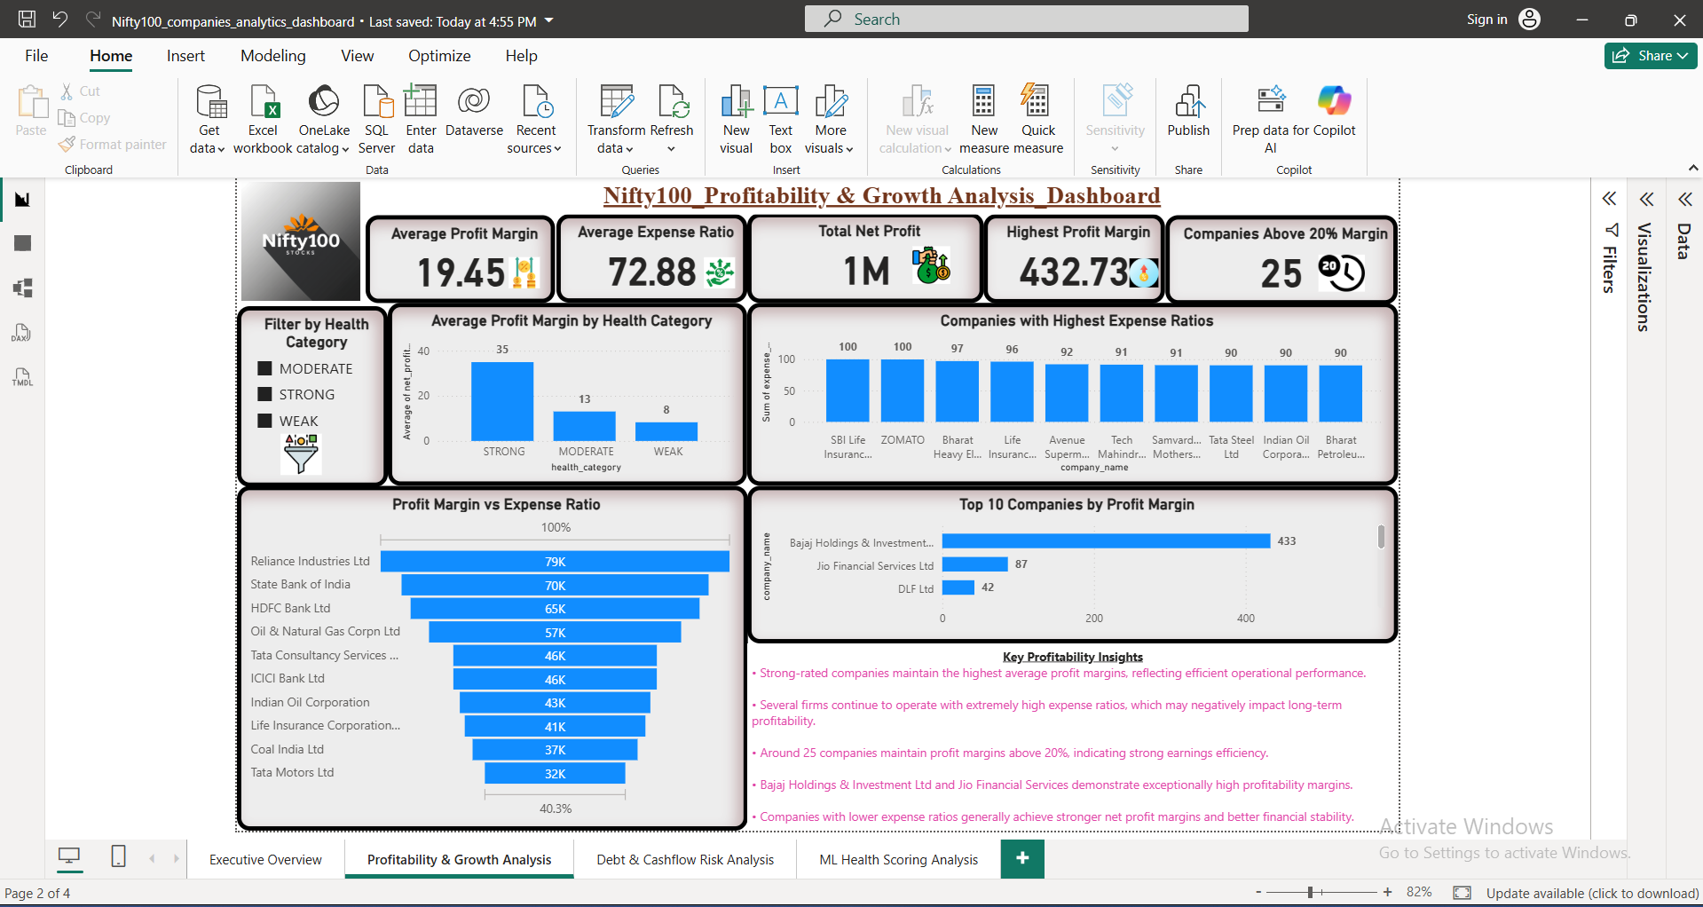

Page 3 — Debt & Cashflow Risk Insights:-

• Weak-rated companies consistently exhibit higher debt-to-equity ratios, indicating elevated financial risk exposure.
• Several firms maintain negative free cash flow positions despite reporting positive profitability figures.
• Companies with lower debt burdens generally maintain healthier cash flow stability and stronger ML health scores.
• Financially stable companies demonstrate balanced leverage and sustainable liquidity positions across operations.
• High debt dependency combined with weak cash generation may create long-term solvency and operational risks.

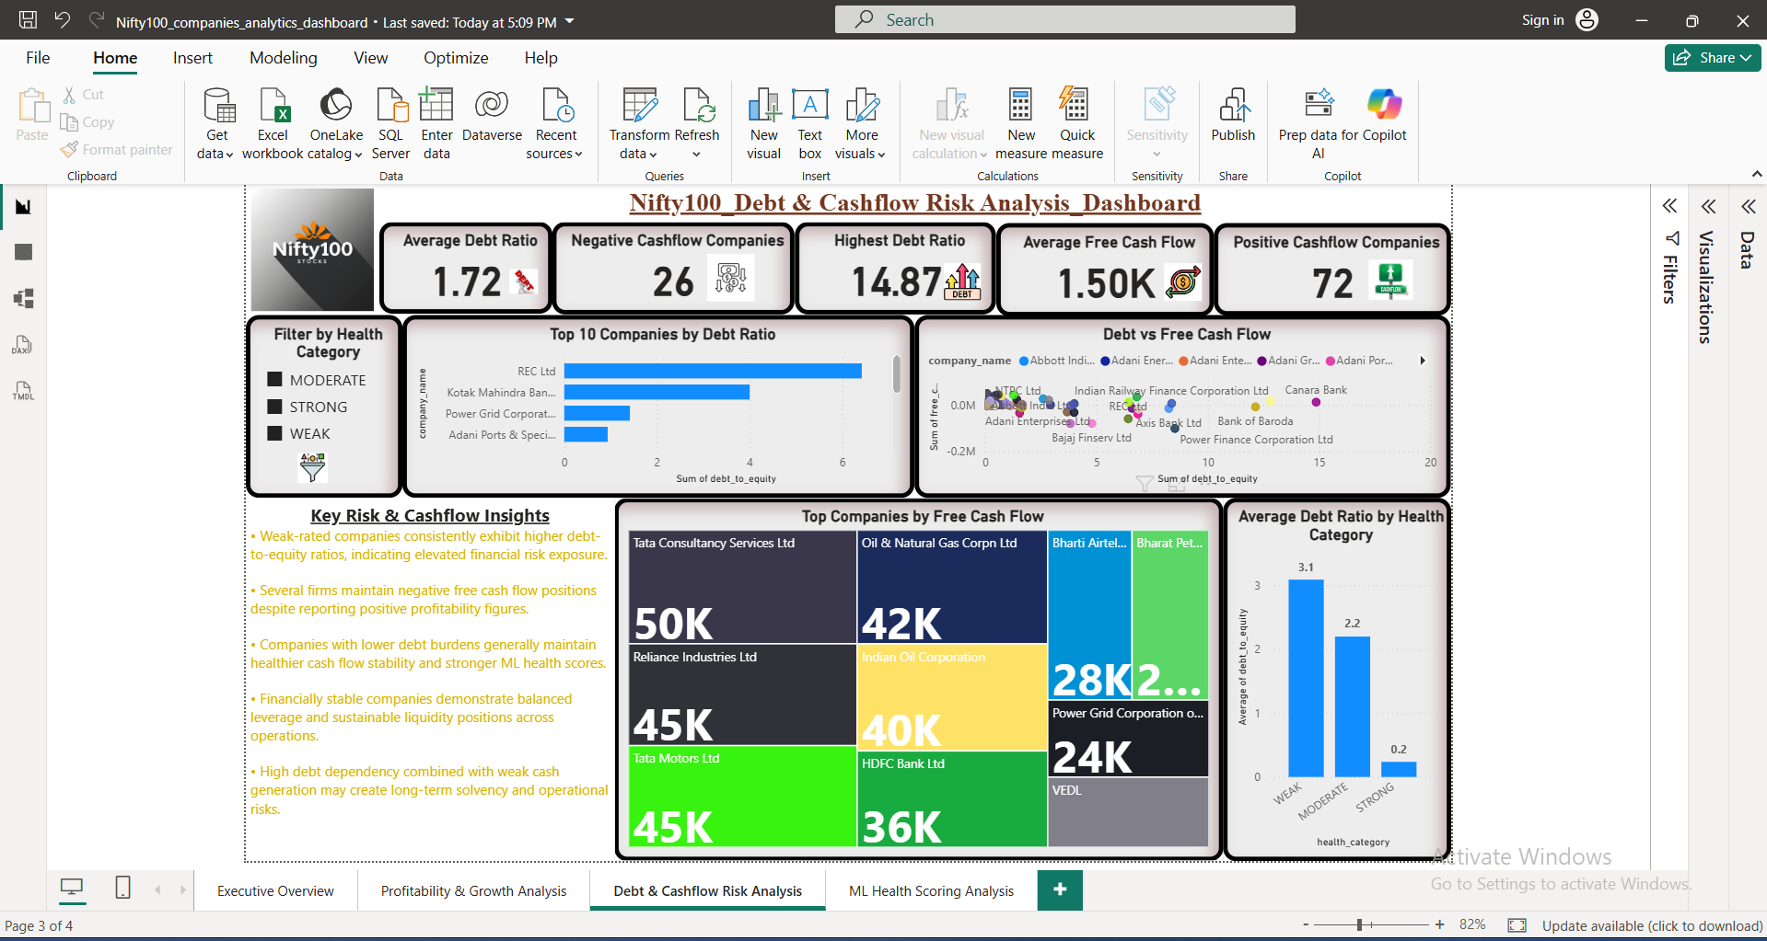

Page 4 — ML Health Scoring Insights:-

• The ML-based health scoring model classifies companies into Strong, Moderate, and Weak financial categories using profitability, debt, cash flow, and expense efficiency metrics.
• Approximately 45 companies fall under the Moderate category, indicating balanced but improvable financial performance.
• Strong-rated companies consistently achieve higher profitability scores while maintaining lower leverage and healthier cash flow positions.
• Weak-rated firms generally demonstrate high debt exposure, unstable liquidity, or weaker operational efficiency metrics.
• Feature contribution analysis highlights profitability and debt management as the strongest drivers influencing overall financial health scores.

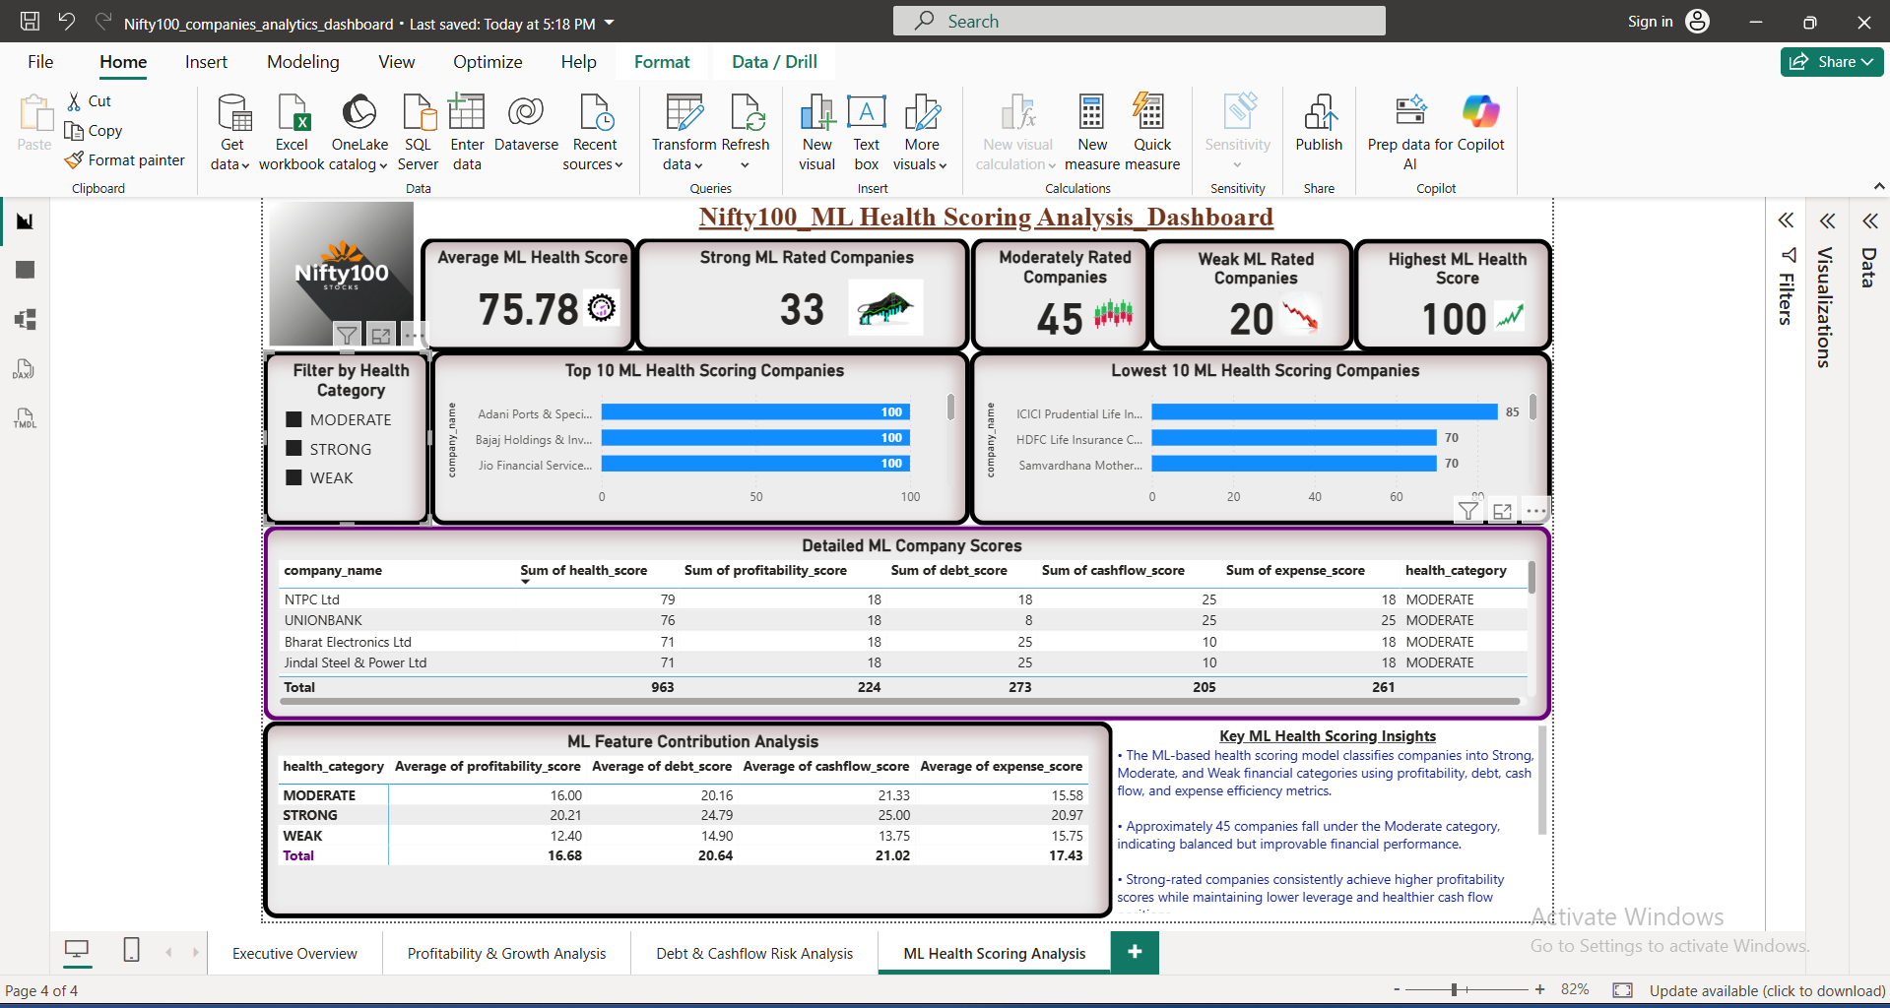

Page 5 — Advanced Final Score Insights:-

• The average overall financial health score across Nifty100 companies is 75.78, indicating generally stable financial performance among large-cap Indian companies.
• Strong-rated companies consistently achieve higher profitability, leverage stability, and long-term financial trend scores compared to weak-rated companies.
• Companies such as Adani Ports, Bajaj Holdings, Coal India, and Jio Financial Services achieved the highest overall financial scores in the analysis.
• The score composition analysis highlights that profitability and leverage management are the most influential components in determining overall company health

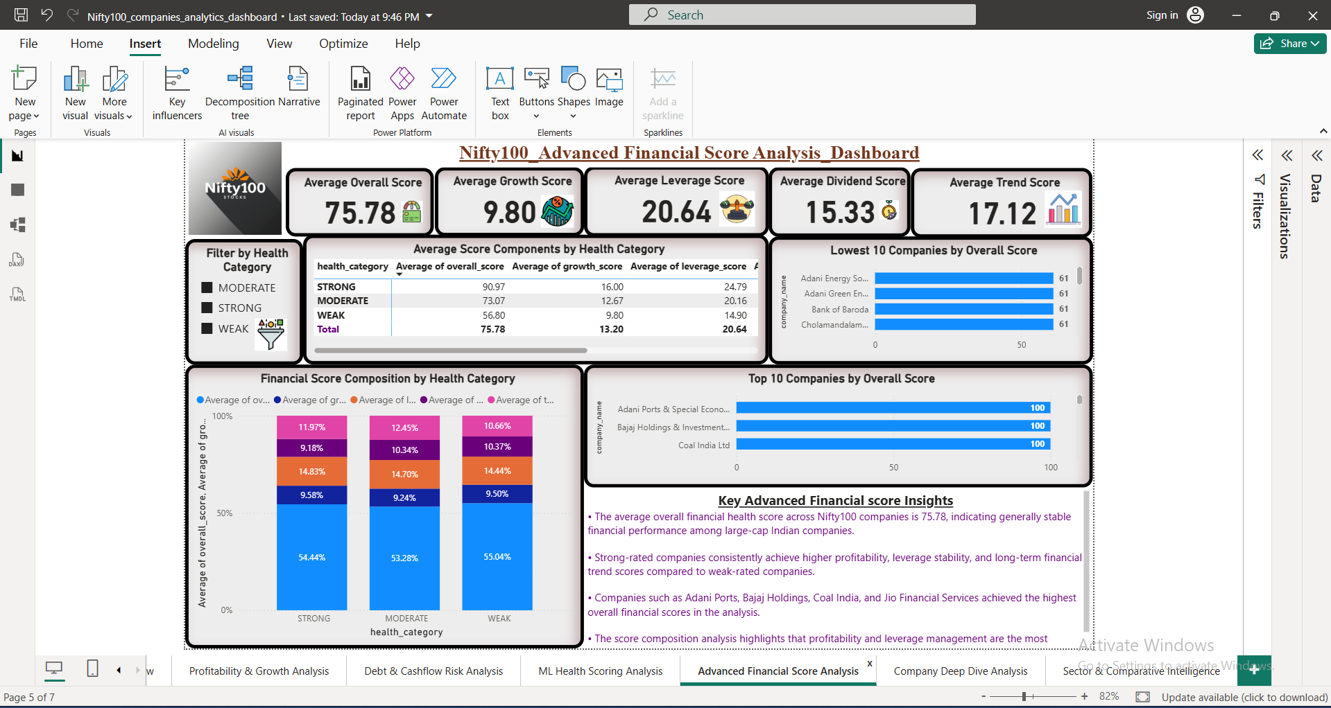

Page 6 — Company Deep Dive Insights:-
• The selected company demonstrates a balanced financial profile through profitability, leverage management, cash flow generation, and overall financial stability indicators.
• Companies with higher overall financial scores generally maintain stronger profit margins, healthier debt structures, and more consistent cash flow performance.
• The financial score breakdown helps identify the strongest and weakest operational areas for the selected company, supporting deeper business analysis.
• Positive free cash flow and stable profitability trends indicate stronger long-term sustainability and operational efficiency.
• The dashboard enables investors and analysts to evaluate company-level financial strength dynamically using advanced ML-driven scoring metrics and financial ratios.

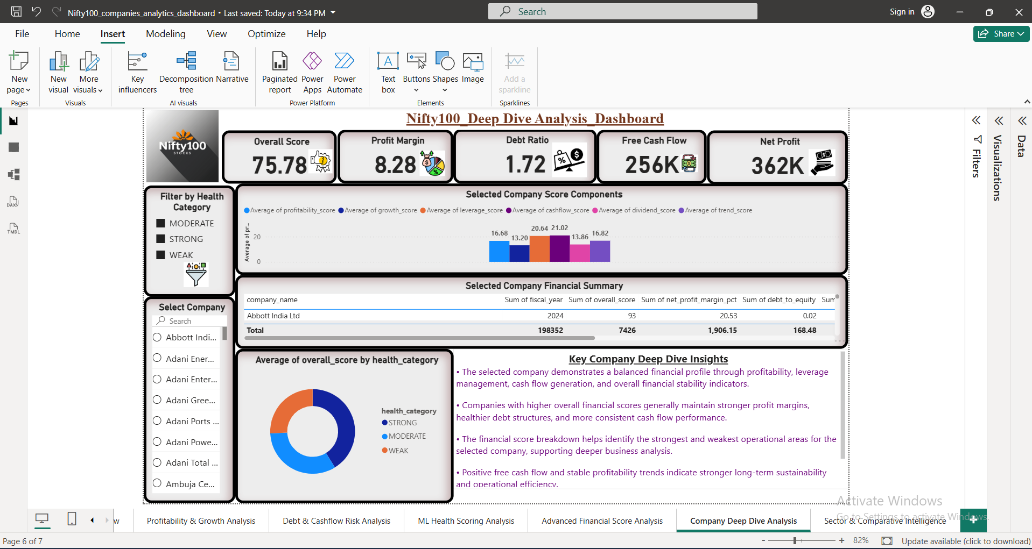

Page 7 — Sector & Comparative Intelligence Insights:-
• The average financial health score across Nifty100 companies is 75.78, reflecting overall stable performance among major Indian sectors and industries.
• IT, FMCG, and Power sectors achieved stronger average financial scores due to better profitability, operational efficiency, and long-term growth stability.
• Strong-rated companies significantly outperform weak-rated companies in growth, leverage management, dividend consistency, and overall financial strength.
• The comparative ranking analysis highlights financially strong companies such as Adani Ports, TCS, Infosys, and Bajaj Holdings as sector leaders based on advanced scoring metrics.
• The sector intelligence matrix enables investors and analysts to compare sector-wise financial performance, identify high-performing industries, and evaluate risk-adjusted investment opportunities effectively.

